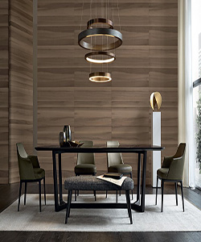

Durian glossy dining table

$163.39

Availability: In stock

Description

Durian Dining Table is a table designed by Emmanuel Galina for Durian. The table has a structure in solid wood, available in three finishes: Canaletto walnut, spessartine oak, caner oak brown olm. The top is available in wood and marble. From 2017 the dining table is also available with top in reflecting glass and glass glossy finishes. Have a look at durian’s range and you’ll find that the style you have always dreamt of actually exists. A design able to propose a primary form that enhances the naturalness of wood. Lightweight shapes interpreted with essential style.